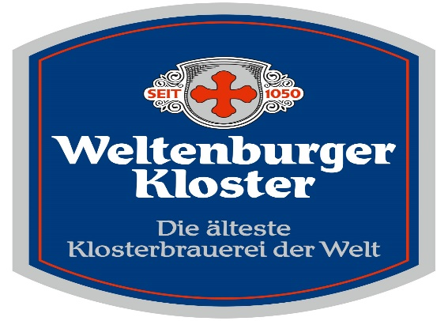
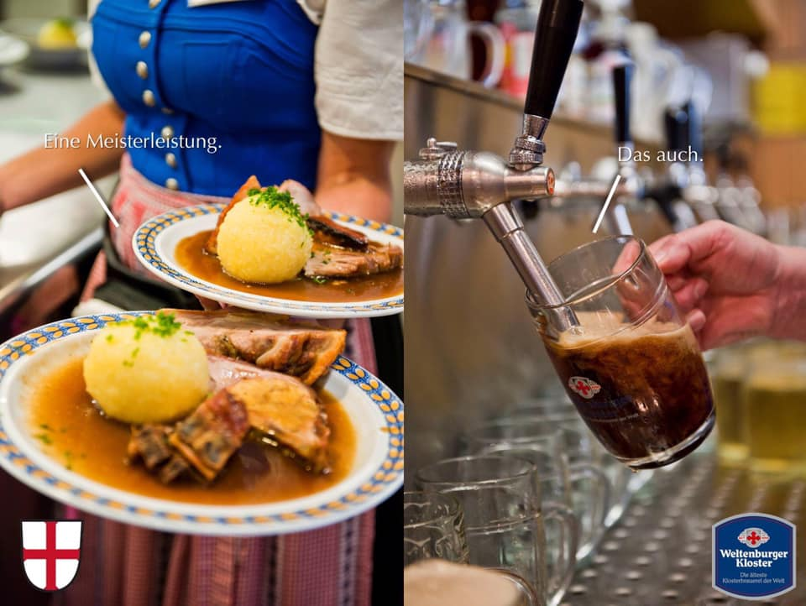
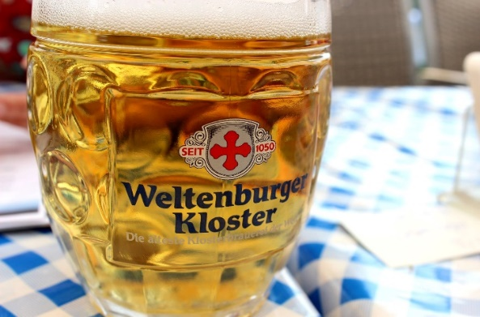
The Weltenburg Monastery Brewery
The oldest monastery brewery in the world, since 1050 in Bavaria
Weltenburger Kloster Anno 1050: Traditional Märzen style lager, the original Oktoberfest style. An elegant, dry yet lightly fruity beer with a medium body. Toasted bready malt flavors along with caramel and toffee. Balance of floral & spicy hop notes with a lingering malty finish and soft carbonation. (5.5 % alc./vol.)
Weltenburger Hefe-Weißbier Hell: Traditional top fermented Bavarian unfiltered wheat beer. Aromas of banana, clove, and citrus. Sweet malt and bready flavors, and spice. Lively and refreshing. (5.4% alc./vol.).

Weltenburger Barock Hell: Light in body & color with a delicate malty sweetness and notes of honey. Mild hop flavors & aromas of fruit & spice. Wonderful session beer and pairs with most any food. (5.6 % alc./vol.).

Weltenburger Kloster Barock Dunkel: The oldest dark beer in the world – a true taste experience; full-bodied, malty, aromatic, smooth and creamy. Intensive flavors of chocolate, nuts, raisins, caramel, cocoa and coffee. Six-time World Beer Cup winner. Dry, elegant and lingering finish with soft carbonation. (4.7% alc./vol.).
Weltenburger Kloster Asam Bock: A strong, dark doppelbock that‘s more than meets the eye. Malty, aromatic, and pleasantly dry with caramel, dark fruit, licorice, and roasted notes. Rich & refined finish. (6.9 % alc./vol.).
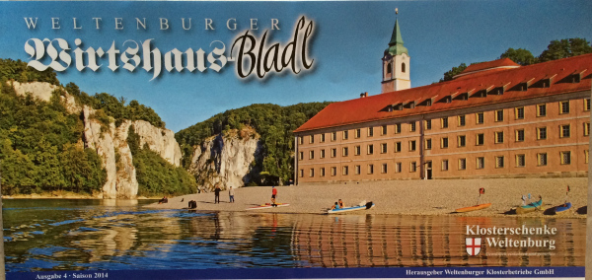
Weltenburger Pils: Beautiful clear straw color with dense white foam. Bright nose of spicy noble hops & subtle citrus. Palate features soft cereal & biscuit flavors, with honey & a touch of earthiness. Clean & light with a crisp finish. (4.9%)

